Honorary Commander Participant Request Form

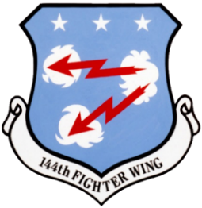
144th Fighter Wing
5323 E. McKinley Ave.
Fresno Air National Guard Base, California

The intent of the Honorary Commanders (H/CC) Program is to pair up base leadership with community leaders to educate our community about the U.S. Air Force, the Air National Guard, the 144th Fighter Wing, and each commander’s individual units. Each honorary commander will be linked with a specific group, squadron, or flight commander.

Each honorary commander’s term is between two to three years. Honorary commanders are considered a member of their unit and are encouraged to attend unit events to gain knowledge and build a strong partnership with their military commander, unit personnel, and the Fresno Team.

The 144th Fighter Wing commander is the approving official for each honorary commander. Honorary commanders may be nominated, or they may self-nominate by completing the information below:

Name: Click/tap here to enter text.

Phone Number: Click/tap here to enter text.

Position/Title: Click/tap here to enter text.

If you are interested in serving as H/CC for a specific unit, please choose your top three units of interest: (Units are organized by Group, -Squadron and --Flight)
First Choice: Choose a unit.
Second Choice: Choose a unit.
Third Choice: Choose a unit.

In a few sentences, why would you like to serve as an honorary commander, and how would you like to fulfill that role? Click/tap here to enter text.
Please send completed digital form to: 144fw.hq.publicaffairs@us.af.mil
Questions may be directed to a unit commander or the 144th Fighter Wing
Public Affairs Office at 559-454-5246

